**PROBLEM USING APRIORI AND FP-GROWTH FOR PRACTICE**

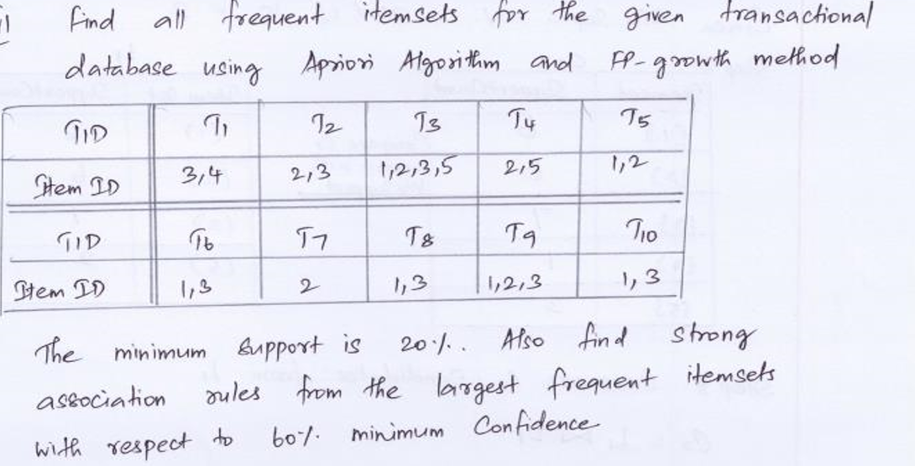

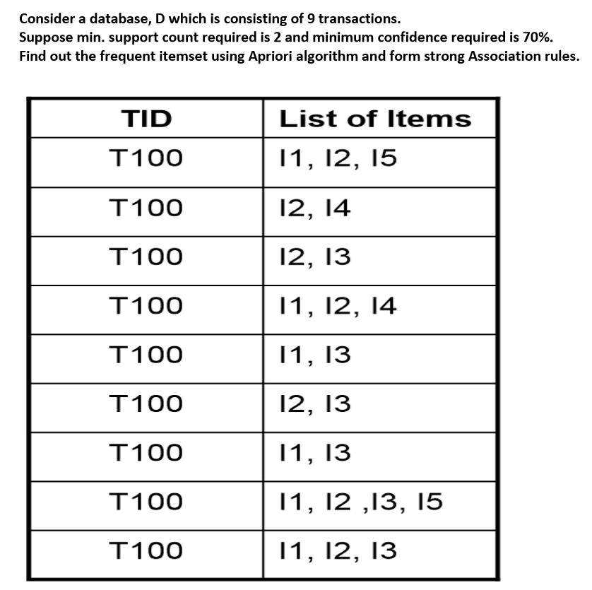

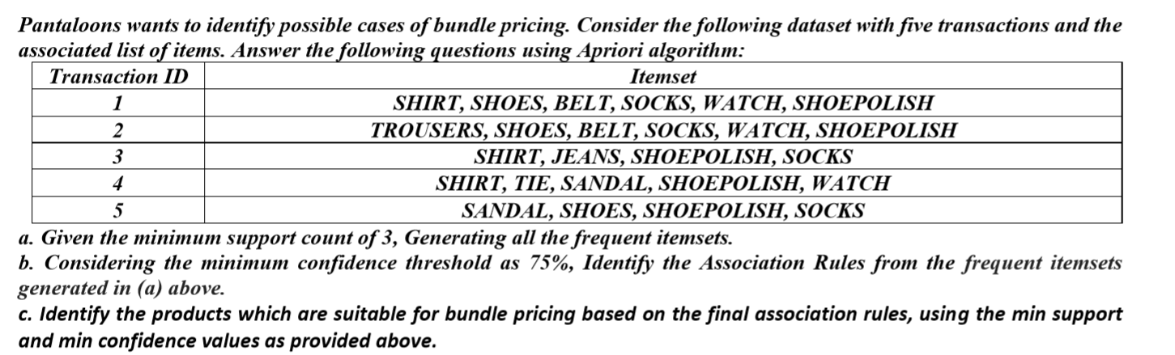

A market basket database has five transactions. Let min sup = 60% and min conf = 80%.

TID items bought T100 Bread, Butter, Beans, Potato, Jam, Milk T200 Bread, Butter, Shampoo, Potato, Jam, Milk T300 Beans, Soap, Butter, Bread T400 Beans, Onion, Apple, Butter, Milk T500 Apple, Banana, Jam, Bread, Butter

i). Find frequent itemsets by constructing FP-tree.

ii. Find the most interesting association rule involving three items.